Отчет по лабораторной работе №2 (Комбинационные и арифметические схемы)

Задание №1

**Шифратор**

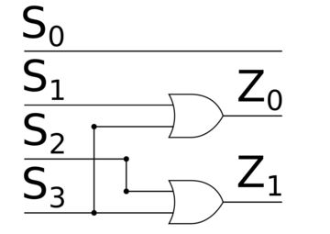

|  |  |  |  |  |
| --- | --- | --- | --- | --- |
| S1 | S2 | S3 | Z0 | Z1 |
| 0 | 0 | 0 | 0 | 0 |
| 0 | 0 | 1 | 1 | 1 |
| 0 | 1 | 0 | 0 | 1 |
| 0 | 1 | 1 | 1 | 1 |
| 1 | 0 | 0 | 1 | 0 |
| 1 | 0 | 1 | 1 | 1 |
| 1 | 1 | 0 | 1 | 1 |
| 1 | 1 | 1 | 1 | 1 |

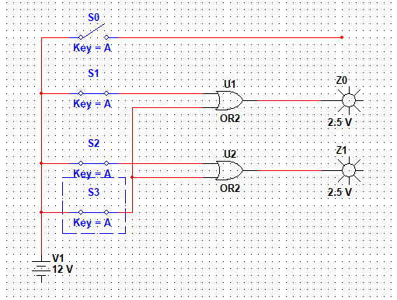

**Дешифратор**

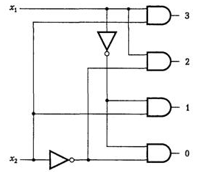

|  |  |  |  |  |  |
| --- | --- | --- | --- | --- | --- |
| X1 | X2 | Y0 | Y1 | Y2 | Y3 |
| 0 | 0 | 1 | 0 | 0 | 0 |
| 0 | 1 | 0 | 1 | 0 | 0 |
| 1 | 0 | 0 | 0 | 1 | 0 |
| 1 | 1 | 0 | 0 | 0 | 1 |

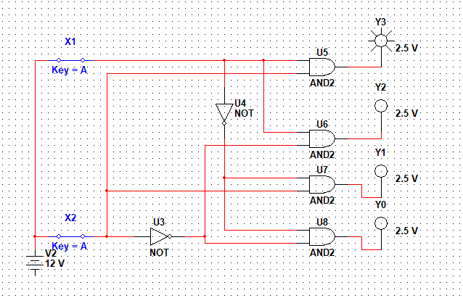

**Мультиплексор**

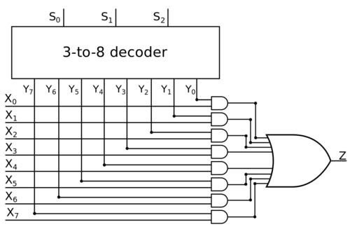

|  |  |  |  |  |  |  |  |  |  |  |  |
| --- | --- | --- | --- | --- | --- | --- | --- | --- | --- | --- | --- |
| S0 | S1 | S2 | X0 | X1 | X2 | X3 | X4 | X5 | X6 | X7 | Z |
| 0 | 0 | 0 | 1 | A | A | A | A | A | A | A | 1 |
| 0 | 0 | 0 | 0 | A | A | A | A | A | A | A | 0 |
| 0 | 0 | 1 | A | 1 | A | A | A | A | A | A | 1 |
| 0 | 0 | 1 | A | 0 | A | A | A | A | A | A | 0 |
| 0 | 1 | 0 | A | A | 1 | A | A | A | A | A | 1 |
| 0 | 1 | 0 | A | A | 0 | A | A | A | A | A | 0 |
| 0 | 1 | 1 | A | A | A | 1 | A | A | A | A | 1 |
| 0 | 1 | 1 | A | A | A | 0 | A | A | A | A | 0 |
| 1 | 0 | 0 | A | A | A | A | 1 | A | A | A | 1 |
| 1 | 0 | 0 | A | A | A | A | 0 | A | A | A | 0 |
| 1 | 0 | 1 | A | A | A | A | A | 1 | A | A | 1 |
| 1 | 0 | 1 | A | A | A | A | A | 0 | A | A | 0 |
| 1 | 1 | 0 | A | A | A | A | A | A | 1 | A | 1 |
| 1 | 1 | 0 | A | A | A | A | A | A | 0 | A | 0 |
| 1 | 1 | 1 | A | A | A | A | A | A | A | 1 | 1 |
| 1 | 1 | 1 | A | A | A | A | A | A | A | 0 | 0 |

* А – может принимать любое значение т.е. ноль или единица. Это значение не влияет на результат в переменной Z.

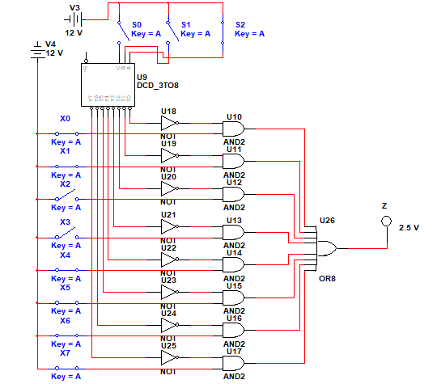

**Демультиплексор**

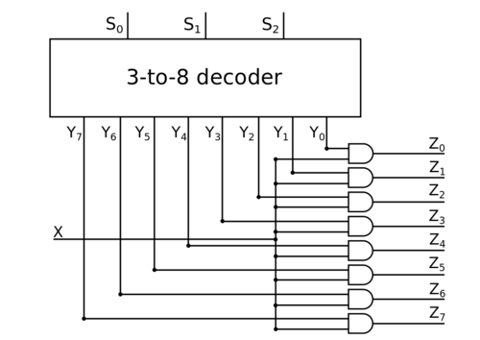

|  |  |  |  |  |  |  |  |  |  |  |  |
| --- | --- | --- | --- | --- | --- | --- | --- | --- | --- | --- | --- |
| S0 | S1 | S2 | X | Z0 | Z1 | Z2 | Z3 | Z4 | Z5 | Z6 | Z7 |
| 0 | 0 | 0 | 1 | 1 | 0 | 0 | 0 | 0 | 0 | 0 | 0 |
| 0 | 0 | 1 | 0 | 1 | 0 | 0 | 0 | 0 | 0 | 0 |
| 0 | 1 | 0 | 0 | 0 | 1 | 0 | 0 | 0 | 0 | 0 |
| 0 | 1 | 1 | 0 | 0 | 0 | 1 | 0 | 0 | 0 | 0 |
| 1 | 0 | 0 | 0 | 0 | 0 | 0 | 1 | 0 | 0 | 0 |
| 1 | 0 | 1 | 0 | 0 | 0 | 0 | 0 | 1 | 0 | 0 |
| 1 | 1 | 0 | 0 | 0 | 0 | 0 | 0 | 0 | 1 | 0 |
| 1 | 1 | 1 | 0 | 0 | 0 | 0 | 0 | 0 | 0 | 1 |
| A | A | A | 0 | 0 | 0 | 0 | 0 | 0 | 0 | 0 | 0 |

* А – может принимать любое значение

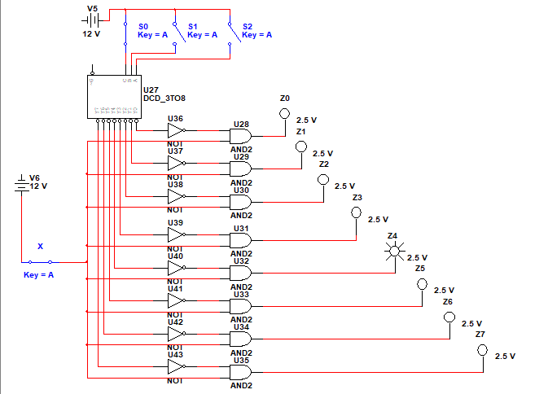

Задание №2

**Полусумматор**

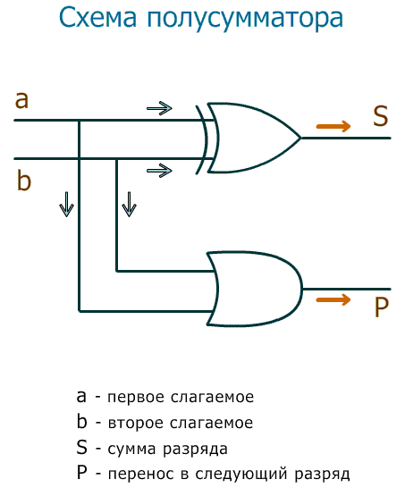

|  |  |  |  |
| --- | --- | --- | --- |
| a | b | S | P |
| 0 | 0 | 0 | 0 |
| 0 | 1 | 1 | 0 |
| 1 | 0 | 1 | 0 |
| 1 | 1 | 0 | 1 |

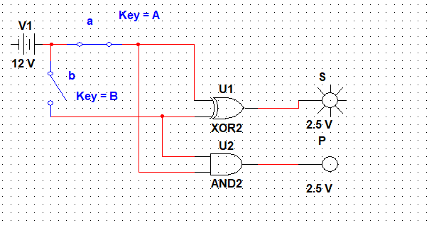

Задание №3

**Полный сумматор**

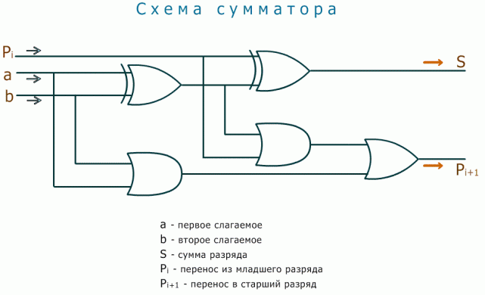

|  |  |  |  |  |
| --- | --- | --- | --- | --- |
| Входы | | | Выходы | |
| a | b | Pi | S | Pi+1 |
| 0 | 0 | 0 | 0 | 0 |
| 0 | 0 | 1 | 1 | 0 |
| 0 | 1 | 0 | 1 | 0 |
| 1 | 0 | 0 | 1 | 0 |
| 0 | 1 | 1 | 0 | 1 |
| 1 | 0 | 1 | 0 | 1 |
| 1 | 1 | 0 | 0 | 1 |
| 1 | 1 | 1 | 1 | 1 |

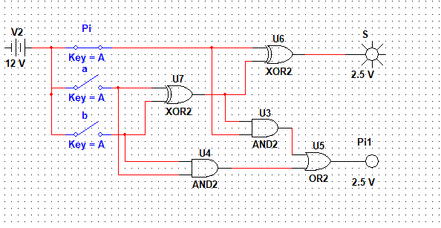

Задание №4

**Схема 4-разрядного сумматора-вычитателя.**



